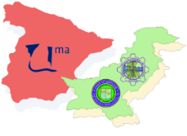
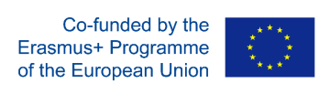
CAPRIO
Mobility Grants
Pakistan to Spain
CAPRIO is an international mobility project funded under the Erasmus+ Key Action 107.
Its aim is strengthening the already existing ties between University of Malaga and the Universities of Mehran and Sir Syed in Pakistan, in order to pursue joint research collaborations within the field of ICT.
Further details at
Projectwebsite: http://www.etsit.uma.es/info/102462/acciones-erasmus-ka1/index_es
Academic Coordinator  MUET | Prof. Dr. Bhawani Shankar Chowdhry | +92-22-2771558 | bhawani.chowdhry @faculty.muet.edu.pk

